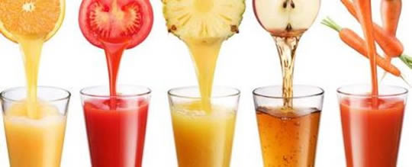
Training Opportunity: Healthy Beverages in Child Care
Training Opportunity: Healthy Beverages in Child Care

If you are a Family Day Care or Group Family Day Care Providers take advantage of this free training and earn credit!
- The Office of Children and Family Services-Division of Child Care Services (OCFS-DCCS) developed regulations for serving healthy beverages in child care.

- This training is available to help you and other providers learn the regulation and how to follow them in your child care program.

- The 45 minute training is available on demand.

- All you need to do is view the training presentation, answer the quiz questions and receive your certificate of training.

- Show your certificate of training to your licensor so they know you are aware of the regulation.

- You may need to install Adobe Flash Player; go to http://get.adobe.com/flashplayer/
Training Opportunity: Healthy Beverages in Child Care
Now is the time; learn about healthy beverages at http://nydontraining.health.state.ny.us/healthy_beverages_in_childcare/event/event_info.html
If you need assistance, email: CACFPadmin@health.state.ny.us
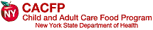
Training Opportunity: Healthy Beverages in Child Care

If you are a Family Day Care or Group Family Day Care Providers take advantage of this free training and earn credit!
- The Office of Children and Family Services-Division of Child Care Services (OCFS-DCCS) developed regulations for serving healthy beverages in child care.

- This training is available to help you and other providers learn the regulation and how to follow them in your child care program.

- The 45 minute training is available on demand.

- All you need to do is view the training presentation, answer the quiz questions and receive your certificate of training.

- Show your certificate of training to your licensor so they know you are aware of the regulation.

- You may need to install Adobe Flash Player; go to http://get.adobe.com/flashplayer/
Now is the time; learn about healthy beverages at http://nydontraining.health.state.ny.us/healthy_beverages_in_childcare/event/event_info.html
If you need assistance, email: CACFPadmin@health.state.ny.us

