_____________________________________________________________________________________


Cornell Cooperative Extension Needs Your Help!

Our mission:
The mission of the New York State Integrated Pest Management Program at Cornell University is to help you prevent pest problems and reduce or eliminate pesticide use in your center.

Why?
Pests and pesticides both pose greater risks to children, with their rapidly growing bodies, than they do to adults.

We need your help!
Help us plan for new programs and materials that in turn will help you deal with the issues and situations at the top of your must-solve list.

Take 10 minutes to complete and submit the survey and we’ll enter your childcare center into a drawing for one of five free site assessments by Cornell University pest management educators.

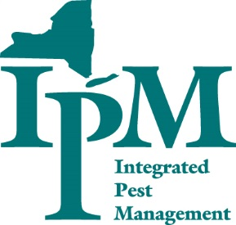
To access the survey, visit: http://tinyurl.com/mmbacar

Integrated Pest Management is your choice for solid science and sound solutions in dealing with pests. We promote safe, least-toxic solutions to both pest and pesticide problems.

Thank you for helping us to help you!

Sincerely,

Joellen Lampman
School and Turfgrass IPM Extension Support Specialist
New York State IPM Program, Cornell University
www.nysipm.cornell.edu
CCE – Albany County
P.O. Box 497, 24 Martin Road
Voorheesville, NY 12186
518-339-8283

