‘Play is our brain's favorite way of learning’
-Diane Ackerman
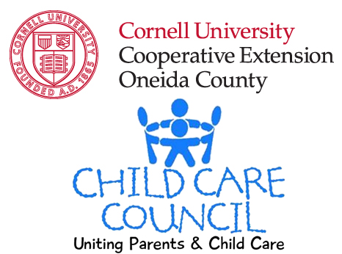

121 Second Street
Oriskany, NY 13424

Telephone: (315) 223-7850
Toll-free: 888-814-KIDS
Fax: (315) 223-7855

www.cceoneida.com/child-care

Satellite Office:

Oneida County DSS
800 Park Ave
Utica, NY 13501
Telephone: (315) 731-3426
(315) 798-5811
Fax: (315) 266-6188

Cornell Cooperative Extension is an employer and educator recognized for valuing AA/EEO, Protected Veterans, and Individuals with Disabilities and provides equal program and employment opportunities

Please contact the Cornell Cooperative Extension of Oneida County office if you have any special needs.

JANUARY 13TH, 2015

Dear Friend,

Although we previously announced the date to be February 21st, the Child Care Council of Cornell Cooperative Extension will be holding the annual Creative Arts & Education Fair on April 18th, 2015 from 10:00 am until 2:00 pm. The fair will be held in its usual location of Mohawk Valley Community College, in the Field House.

The purpose of the fair is to provide children ages 2 to 12 with interactive educational and creative arts activities, while at the same time offering parents a forum at which they can receive information on the many wonderful services offered to them and their families.

If your organization provides a service that benefits children, families or adults (who will attend with their children), you are invited to participate! I invite your organization to take part in the Fair by hosting a booth that provides a hands-on activity for children. You are also welcome to provide information on your organization’s services. In previous years we had as many as 500 people in attendance. As a participant, you will receive free publicity as well as have mention in our brochure, so this is truly a great way to advertise your program!

Please note that in keeping with the theme of a “creative arts” fair, you MUST provide an activity for children at your booth. Please keep in mind that loose-food, open liquid or sand activities are prohibited in the facility.

We hope that you will be part of what we anticipate to be the most successful fair yet! To participate, please fill out the attached registration form and return it to me at the Child Care Council by Wednesday, March 25th. If you have any questions, please contact me at (315) 223-7850 x 230.

Thank you in advance for your support of our community’s children and families. Hope to see you on April 18th!
Sincerely,
Courtney Jenne
Courtney Jenne
Public Relations Sr. Asst/Corporate & Community Relations
(315) 223-7850 x 230
caj88@cornell.edu
Thank you for agreeing to participate in this collaborative event on Saturday, April 18th, 2015 from 10 a.m. to 2 p.m. at the Mohawk Valley Community College Field House, 1101 Sherman Drive, Utica, NY 13501 (parking available behind field house off Armory Drive). To complete your registration and reserve a booth at this event, please complete this form and return it to the Child Care Council no later than Wednesday, March 25th. PLEASE! Don’t sign up if you cannot commit to the entire time from 10 a.m. to 2 p.m. (Those booths that close up and leave early will not be invited back next year.)

NAME OF PROGRAM ____________________________________________________________

ADDRESS _____________________________________________________________________

CONTACT PERSON _____________________________________________________________

CONTACT PHONE _______________________ CONTACT EMAIL ________________________

Number of: tables needed ____________ chairs needed _______________

Though space and electric is limited, we will do our best to accommodate your needs. Please bring your own extension cords if needed.

Please describe the creative arts, science or other hands-on activity that your program is planning on doing. No large motor activities, and please make sure all materials used are non-toxic! Please keep in mind that loose food, open liquid or sand activities are prohibited in the facility. Also list any special space requirements you need (electrical outlet, etc.). __________________________________________________________________________________________________________________________________________________________________________________________________________________________________________

EACH PROGRAM IS RESPONSIBLE FOR ITS OWN ACTIVITY!! You will be able to enter the Field House at 8:30a.m. to provide you with enough time to set up your booth. Please have your booth set up and ready to go before the Fair begins at 10a.m. Please bring a table covering for your table. Programs are responsible for cleaning up their area after the Fair ends at 2 p.m., and everyone will need to be cleared from the Field house by 4 p.m. Please be sure you have staff staying after the Fair ends to clean up your group’s area!
I ________________________________________ am agreeing to participate in the above named event on Saturday April 18th, 2015 and guarantee that our booth will be set up and maintained from 10 a.m. to 2 p.m., providing activities for attendees.

PLEASE SIGN and RETURN THIS COMPLETED FORM, WITH A CERTIFICATE OF LIABILITY INSURANCE NAMING CORNELL COOPERATIVE EXTENSION AS THE CERTIFICATE HOLDER, BY WEDNESDAY, MARCH 25TH 2015.

The Child Care Council of Cornell Cooperative Extension Attn: Courtney Jenne
121 Second Street
Oriskany, NY 13424
Fax: (315) 223-7855
For additional information, contact Courtney Jenne at 223-7850 x 230 or caj88@cornell.edu

