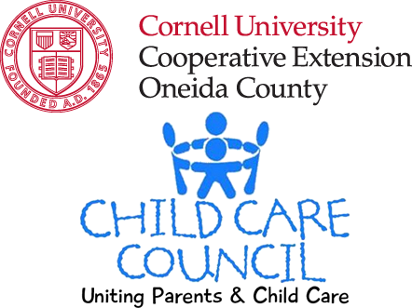
Child Care Council of Cornell Cooperative Extension 2016 Advocacy Agenda

Servicing Herkimer, Madison & Oneida Counties
According to Schuyler Center for Analysis and Advocacy, 85% of a child’s brain development occurs before the age of five. Participating in a high quality early learning program has been shown to provide children with better math skills, fewer behavioral issues prior to entering school. According to America’s Edge, children who participate in a quality early learning program are 31% more likely to maintain gainful employment, 36% earn more in their professions and they are four times more likely to obtain a four year degree as an adult. New York State has the opportunity to provide a continuum of high-quality early learning programs that would transform our economy, as well as our educational, human services and criminal justice systems. We cannot wait to implement a strategic, system-building approach that supports positive outcomes for children and parents. The time to make the investment is NOW.
Investing additional funds in child care will…
- Support New York’s implementation of the Child Care and Development Block Grant Act (CCDBG) requirements which promote children’s safety and well-being and improved child care program quality.
- Provide additional subsidy funding to reach an additional 13,000 children in NYS, who live in income-eligible families and are waiting for subsidies.
- Support the local economy by ensuring that working parents have access to quality and affordable child care.

- Child Care and Development Block Grant Act (CCDBG)
We applaud and thank our elected officials for approving passage of the bill. The passage of CCDBG provides increased measures to ensure child safety, i.e. background checks, 100% site visits and pre-service training (which are all things CCR&R’s have advocated for) Our concern is with the level of funding being provided to support these measures. If it is not adequate, the County may get a smaller allocation for actual subsidies. In order for the re-issuing of this bill to be successful, the funding must be supplied by an area other than subsidy funding.
- Child Care Subsidy Funding
Oneida County DSS reduced the number of people eligible for child care subsidy from 200% of Federal Poverty Level to 150% of. Despite implementing this strategy, the demand exceeded the funding in 2014-15 FY, and from January of 2015 to January of 2016, no new cases were opened. As a result of this, families in Oneida County were denied access to child care subsidy for over a full year.
The Workforce Development Institute administers subsidy via facilitated enrollment to families up to 275% of FPL, in Oneida County. Currently, the WDI is also not taking any new cases. Findings from WDI indicate that parents who participate in Facilitated Enrollment experience decreased tardiness and absenteeism. In order to ensure that parents have the child care they need to successfully get and keep employment, we must examine the level of funding for child care subsidy.
3) Access to Quality and Affordable Child Care
Parent Co-Pay Requirements are calculated as a percentage of the family’s income above the Federal Poverty level and varies by county, ranging from 10% to 35% . In Oneida County: for a family of 3 at 150% federal poverty level or $29,295/year the parent copay is set at 25% of the market rate cost of their child care. This means that a family would pay $4,883/year or $93.90/week which is about 16.7% of their income. In Herkimer County: Family of 3 at 200% FPL or $39,060/year, the parent co-pay at 35%, so they can be eligible at a higher household income, but have to contribute a higher percentage of the market rate cost of their child care. Translates to $6,836/year or $131.45/week (17.5% income). In Madison County: Family of 3 at 200% of FPL or $39,060/year, the parent co-pay at 25%, translates to $4,883/year or $93.90/week (12.5% of income)
According to a CNNMoney article (Nov 2013) the average cost of center based child care in NYS is nearly $15,000/year, a cost greater than some college tuitions.

Average Annual Cost of Center-Based Child Care
New York State | Oneida County | Herkimer County | Madison County
$15,000 | 6 weeks – 5 years  $8,047/year | 19 months – 5 years  $9,100  No center-based infant care available | 6 weeks – 5 years  $9,555

According to Massachusetts Institute of Technology’s living wage calculator for Oneida County, child care is the highest household expense, surpassing mortgage or rent. For low income families, this is an even heavier burden when child care subsidies are not available. Without an increase in the state’s investment, parents’ ability to provide financial stability for their family and a supportive learning environment for their children is being seriously undermined.
Child Care Council of Cornell Cooperative Extension 2016 Advocacy Agenda

Servicing Herkimer, Madison & Oneida Counties

